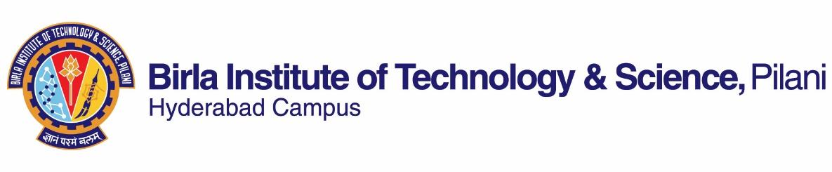

**SECOND SEMESTER 2022-2023**

# Course Handout Part II

Date: 13-03-2023

In addition to part-I (General Handout for all courses appended to the time table) this portion gives further specific details regarding the course.

*Course No.* : BITS F112

## Course Title : Technical Report Writing

## Instructor-in-Charge : Dr Maya Vinai

Instructors : Prof. M.G Prasuna & Dr. Santosh Mahapatra

**Scope and Objective of the Course:** The main objective of the course is to help the learners develop skills in writing technical reports and making academic presentations. The focused skill areas are meant to enable students to write their PS, LoP/DoP reports and theses.

**Textbooks (TB):**

1. Hewings, M.and Thaine, C. 2014. *Cambridge Academic English (Advanced) Student’s Book*. First South Asian Edition. Cambridge University Press.

**Reference books**

1. Sarah Philpot and Lesley Curnick. 2013. *Headway Academic Skills: Introductory: Listening, Speaking, and Study Skills Student's Book*. OUP.
2. Stephen Bailey. 2017. *Academic Writing: A Handbook for International Students*, 5th edition. London: Routledge.
3. Rhonda Liss and Jason Davis. 2012. *Effective Academic Writing (The Researched Essay) 3. Second Edition*. OUP

* Relevant materials from the web will also be used.

1. ) **Course Plan:**

|  |  |  |  |
| --- | --- | --- | --- |
| **Lecture No.** | **Learning objectives** | **Topics to be covered** | **Chapter in the Text Book** |
| 1-2 | Recognize different elements and aspects of the course; identify the difference between general and academic communication | Course Overview  Importance, objective, process, Types, Barriers | Web |
| 3- 5 | Create outlines, organize and prepare notes on the basis of their reading of academic texts | Reading short articles, reports and making notes  Strategies for note-making | T.B. Unit 1, 5, 9, 10 |
| 6-8 | Select information and create notes while listening to academic lectures | Listening to presentations/lectures  Note-taking strategies | T.B Unit 2  &  Web-based sources |
| 9- 14 | Apply basic elements of writing academic paragraphs and differentiate between different kinds of paragraphs, write e-mails effectively | Words, phrases, linkers and appropriate sentence structures  Paragraph writing  E-mail writing | T.B Unit 1, 2  and  Web based Sources |
| 15-18 | Create concise versions of academic texts and restate academic texts in an original manner | Summarizing and paraphrasing | T.B Unit 2 |
| 19 | Technical Reports:  Understanding Reports: Definition, Importance, Characteristics, different types and aspects of technical reports | Understanding formal reports, types of reports; Informational, Interpretive, Routine;  Academic reports | Web and T.B. |
| 20-27 | Evaluate the content and language of each section of a report | Structure of reports and method and sources of data: Abstract/executive summary; title and contents pages; introduction; methods; results; discussion and conclusion; references | T.B. Units 5-10 |
| 28-30. | Develop an outline for a presentation; select and use appropriate technological tools, list the components, select content and utilize appropriate language | Oral presentation and use of illustrations: Structure, outline, delivery modes, body language and voice, visual aids | T.B. Unit 4-10 |

**Evaluation Scheme:**

|  |  |  |  |  |
| --- | --- | --- | --- | --- |
| **Component** | **Duration** | **Weightage (%)** | **Date & Time** | **Nature of Component** |
| Mid Semester Examination | 90 minutes | 30 | 3/05/2023 (3.30-5.00 pm) | Closed Book |
| Assignments 1 and 2 | NA | (15+15 =30) | (To be announced) | Open Book |
| Comprehensive Examination | 180  minutes | 40 | 05/07 (FN) | Closed Book |

**Chamber Consultation Hour:** Slots will be decided in the classroom.

**Notices:** Notices concerning the course will be displayed on the CMS.

**Make-up Policy:** Make-up will be given only in genuine cases (subject to verification)

**Academic Honesty and Integrity Policy:** Academic honesty and integrity are to be maintained by all the students throughout the semester and no type of academic dishonesty is acceptable.

Dr. Maya Vinai

**INSTRUCTOR-IN-CHARGE**